

Managing Inventory Adjustments – Inventory Control Team

The following guide provides users with the steps necessary for the Inventory Control team to manage inventory adjustments in Oracle. This guide includes steps on how to issue PRJ or COMMON inventory to a project, process inter-company purchases, manage scrap, and review on-hand inventory.
Contents
Process an Intercompany Sale to Clearwave/Fidelity/Valunet (COMMON): 3
Business Procedure Description: 3
Prerequisites: 3
Output/Next Steps: 3
Tips/Additional Information: 3
Process an Intercompany Purchase from Clearwave/Fidelity/Valunet (COMMON): 8
Business Procedure Description: 8
Prerequisites: 8
Output/Next Steps: 8
Tips/Additional Information: 8
Process a Third-Party Sale Using COMMON Inventory: 17
Business Procedure Description: 17
Prerequisites: 17
Output/Next Steps: 17
Tips/Additional Information: 17
Where to get more information 23

Process an Intercompany Sale to Clearwave/Fidelity/Valunet (COMMON):

Business Procedure Description:
The purpose of this transaction is to process an intercompany sale to Clearwave, Fidelity, or Valunet from COMMON inventory

Prerequisites:
None

Output/Next Steps:
Intercompany sale is processed

Tips/Additional Information:
None

- Log into Oracle and select the Inventory Management icon 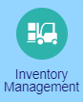 to go to the Inventory Management screen.

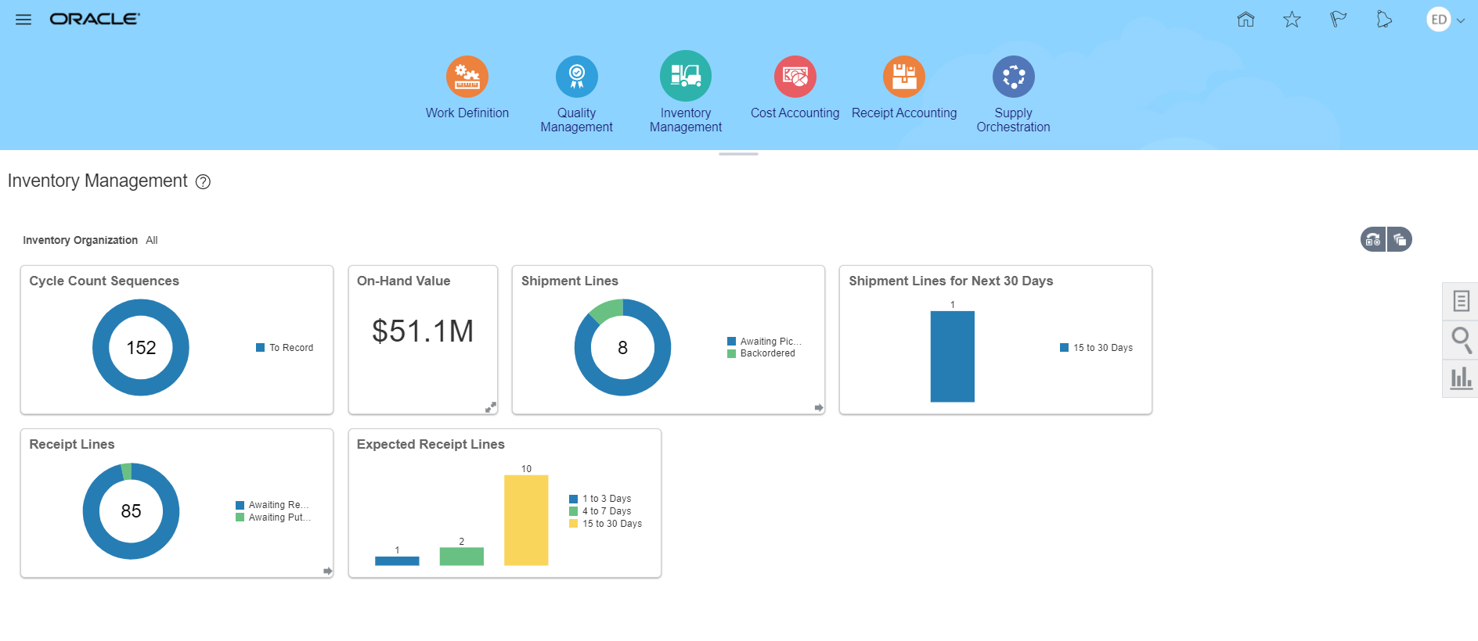
- Click the Tasks icon :
- In the Inventory section, select Create Miscellaneous Transaction to go to the Create Miscellaneous Transaction screen.
 A Select Organization window may display once you access the Create Miscellaneous Transaction screen. Enter the appropriate 4 digit code (e.g. CBAY) in the Organization field and click the OK button 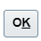 to continue.

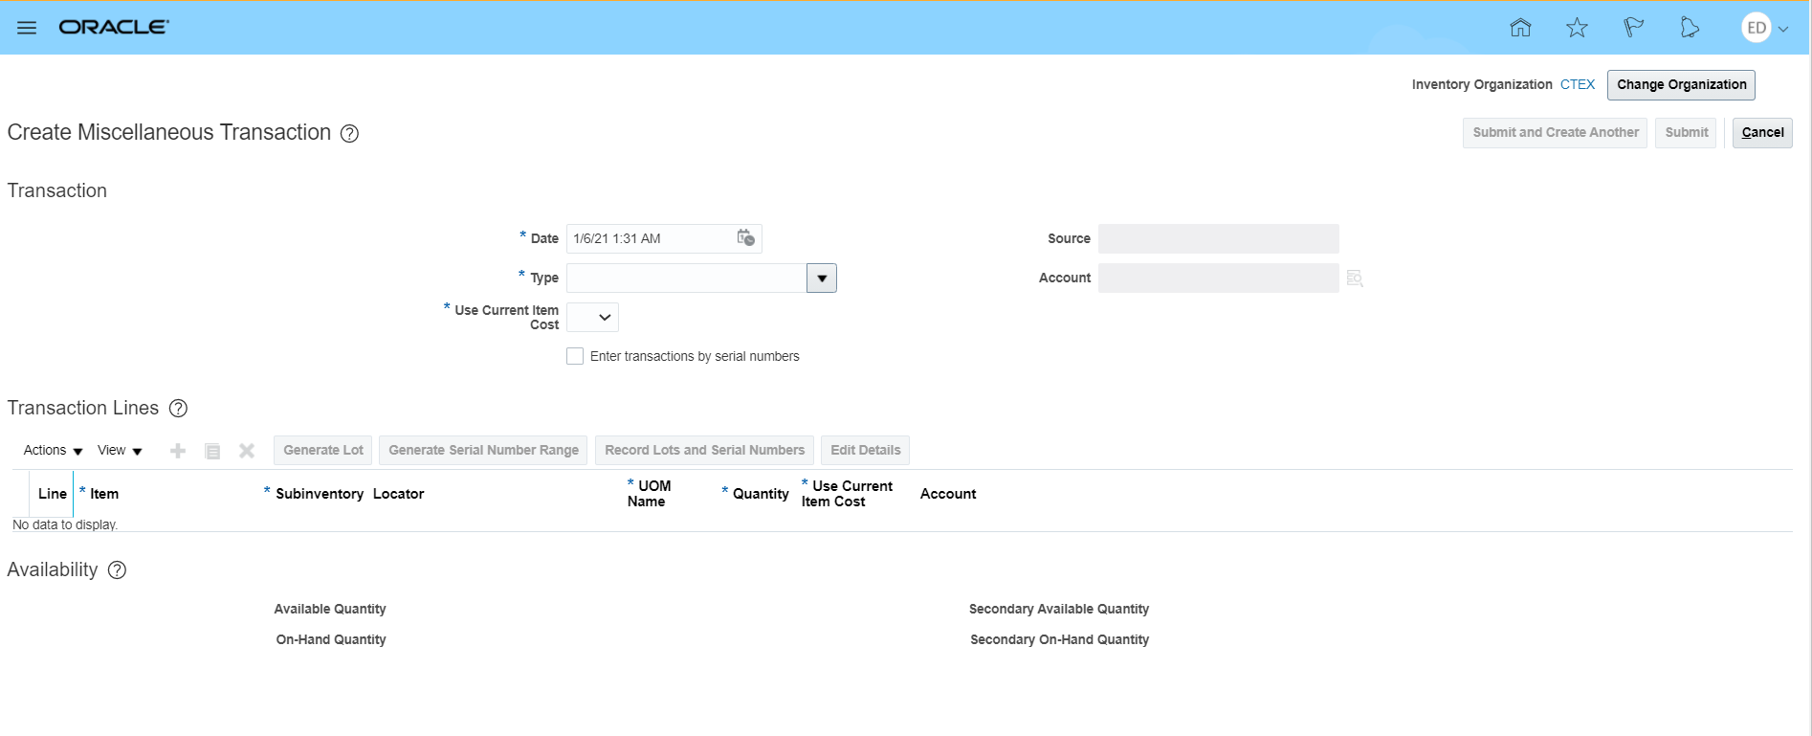
- In the Type field, click the drop-down arrow 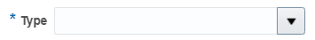 and select Account Alias Issue.
- In the Use Current Item Cost field, click the drop-down arrow 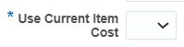and select Yes.
- In the Source field, type: 4-digit code Sale to XXXX (e.g. CXXXX Sale to Clearwave, CXXXX Sale to Fidelity, CXXXX Sale to Valunet).
- Click the Select: Source icon to display the Source window.
- Click the Search button .
- Click the OK button  to return to the Create Miscellaneous Transaction screen.

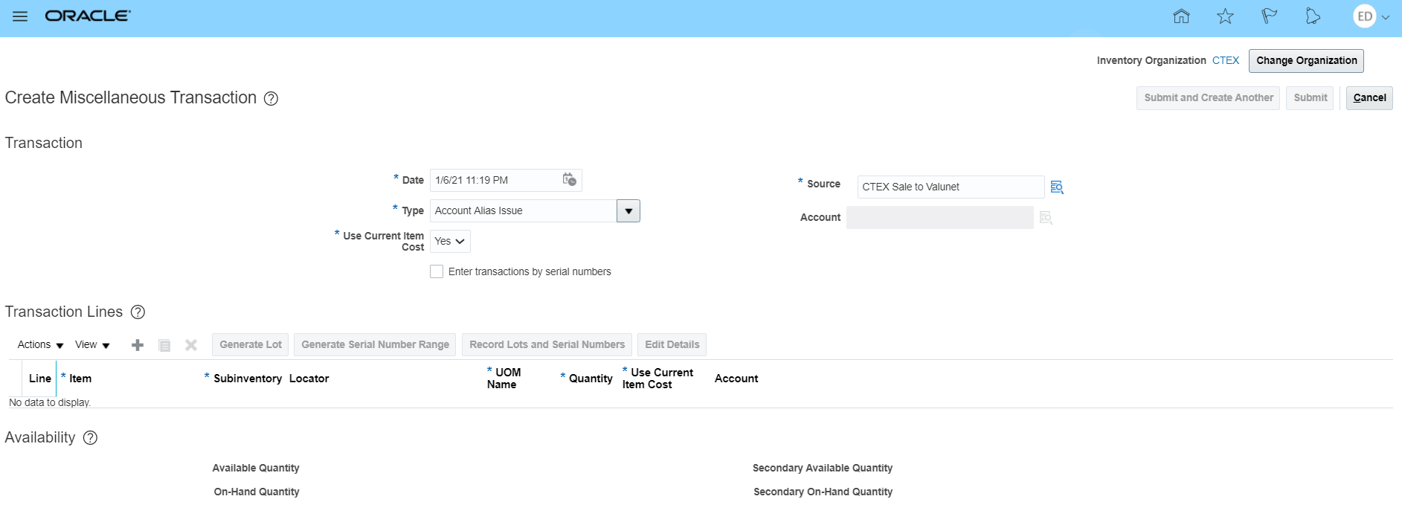
- In the Transaction Lines section, select the Add icon to add a line item.
Is it recommended that you add the Item Description column to your transaction. To add the Item Description column:
- Click the View drop-down arrow
- Select Columns
- Scroll to the bottom of the list and select Item Description

- Enter the Item number in the Item field and click the Subinventory field to continue.
- Click the drop-down arrow  in the Subinventory field and select MAIN or AVA.
- Click in the Quantity field and enter the quantity being sold.
- Click the Submit button  to display the Confirmation window.
The system displays the message: Your transaction processed with no issues.

- Click the OK button 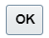 to accept the message and return to the Inventory Management screen.
- You have completed this transaction.

Process an Intercompany Purchase from Clearwave/Fidelity/Valunet (COMMON):

Business Procedure Description:
The purpose of this transaction is to process an intercompany purchase from Clearwave, Fidelity, or Valunet

Prerequisites:
For intercompany purchases, you need to know two pieces of information before recording this transaction:
- The per item cost for each item purchased
- The per item tax amount for each item purchased

Output/Next Steps:
Intercompany purchase is processed

Tips/Additional Information:
None

- Log into Oracle and select the Inventory Management icon to go to the Inventory Management screen.

- Click the Tasks icon :
- In the Inventory section, select Create Miscellaneous Transaction to go to the Create Miscellaneous Transaction screen.
A Select Organization window may display once you access the Create Miscellaneous Transaction screen. Enter the appropriate 4 digit code (e.g. CBAY) in the Organization field and click the OK button to continue.

- In the Type field, click the drop-down arrow and select Account Alias Receipt.
- In the Use Current Item Cost field, click the drop-down arrow and select No.
- In the Source field, type: 4-digit code Purch from XXXX (e.g. CXXXX Purch from Clearwave, CXXXX Purch from Fidelity, CXXXX Purch from Valunet).
- Click the Select: Source icon to display the Source window.
- Click the Search button .
- Click the OK button to return to the Create Miscellaneous Transaction screen.

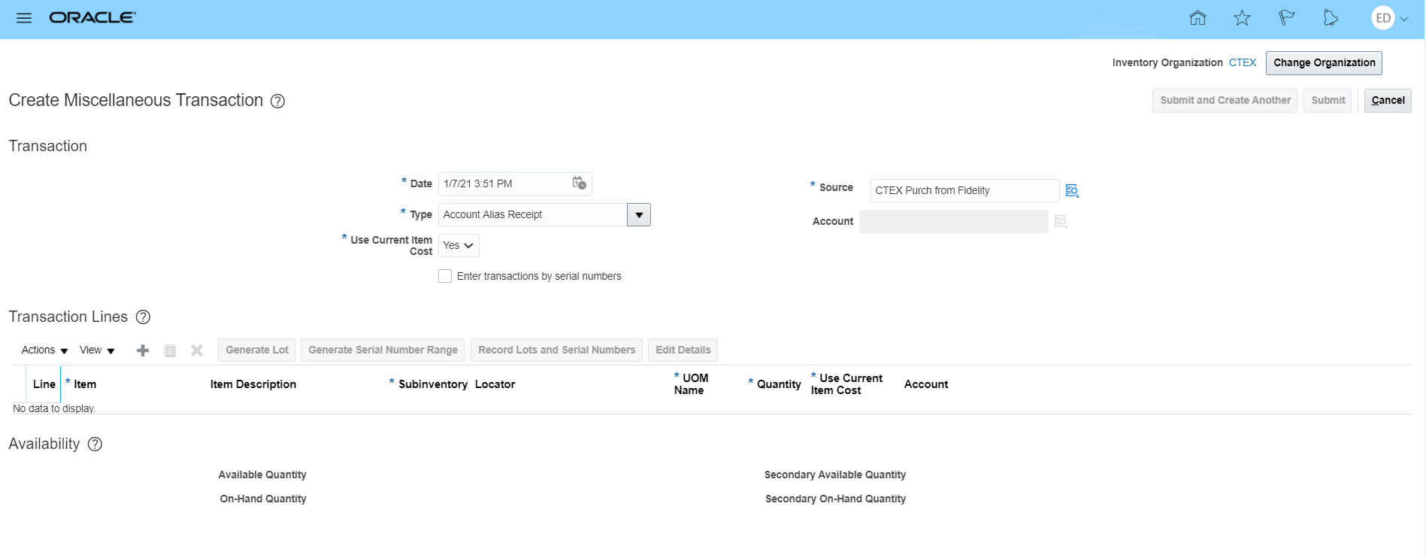
- In the Transaction Lines section, select the Add icon to add a line item.
Is it recommended that you add the Item Description column to your transaction. To add the Item Description column:
- Click the View drop-down arrow
- Select Columns
- Scroll to the bottom of the list and select Item Description

- Enter the Item number in the Item field and click the Edit Details button to go to the Create Miscellaneous Transaction Line: 1 screen.

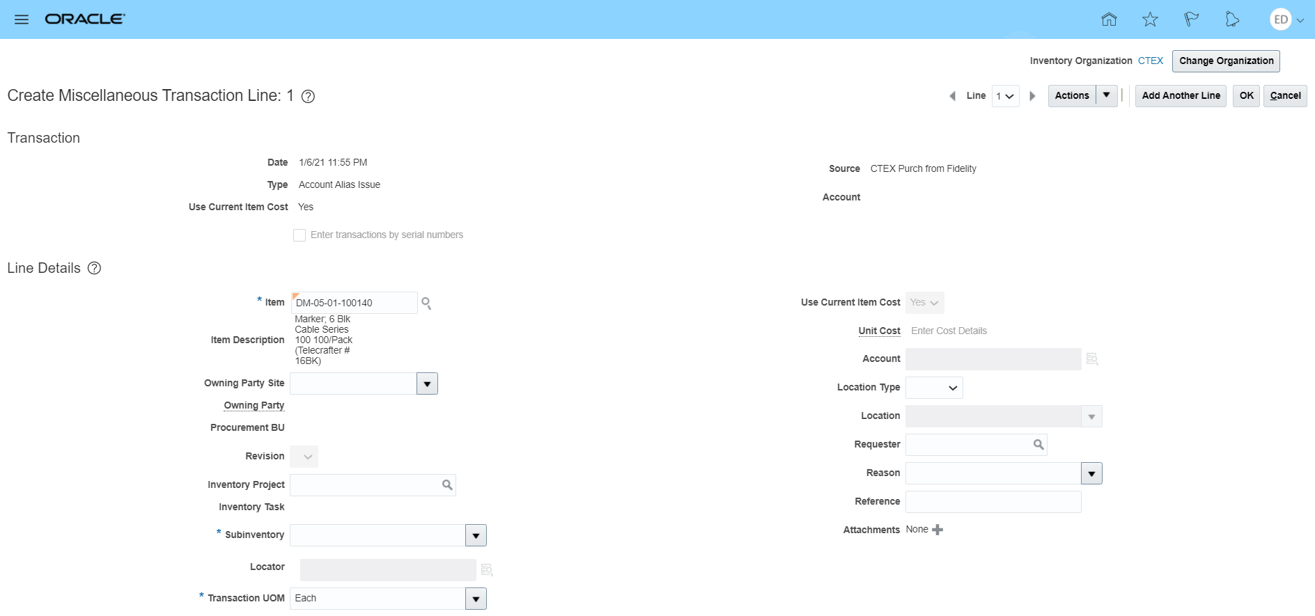
- Click the drop-down arrow in the Subinventory field and select MAIN or AVA.
- Enter the Transaction Quantity in the Transaction Quantity field.
- Click the Enter Cost Details hyperlink in the Unit Cost field  to display the Enter Cost Details: Line 1 window
If the hyperlink is not available to select, click the drop-down arrow in the Use Current Item Cost field and select No 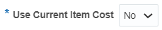. The Enter Cost Details hyperlink is now available to select.

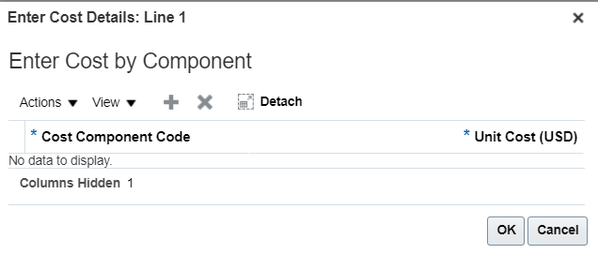
- Select the Add icon to add a line item.
- Click the drop-down arrow  in the Cost Component Code field and select Item price.
- In the Unit Cost field, enter the per item price.
- Select the Add icon to add a line item.
- Click the drop-down arrow in the Cost Component Code field and select Nonrecoverable Tax.
- In the Unit Cost field, enter the per item tax.
- Click the OK button 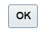 to return to the Create Miscellaneous Transaction: Line 1 screen.

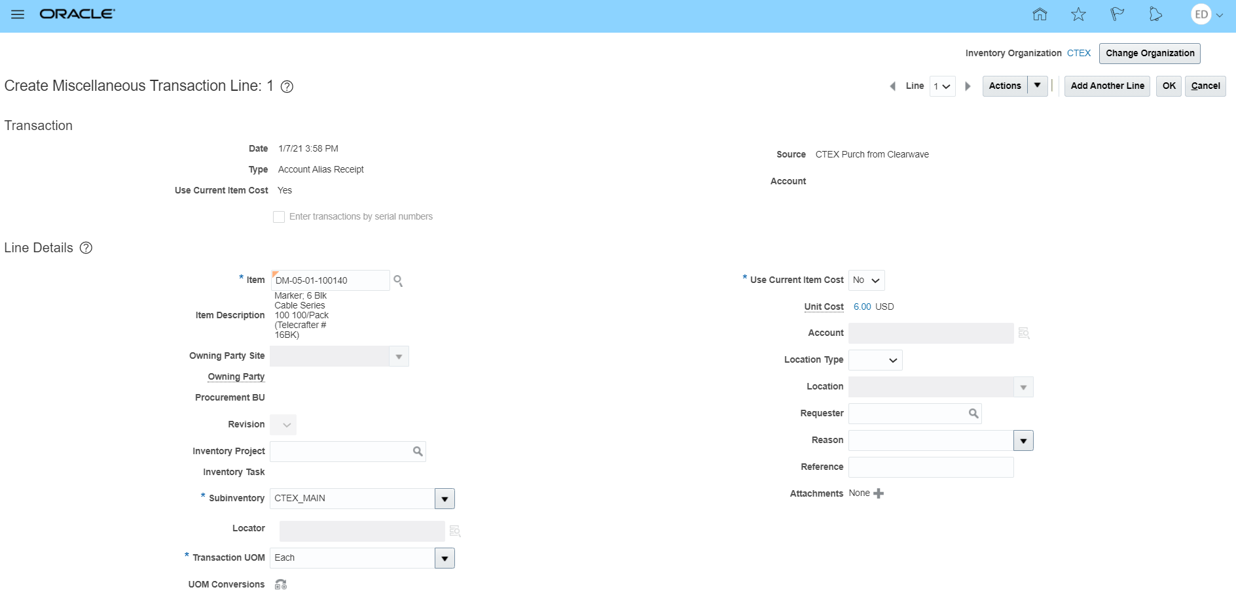
- Click the OK button to return to the Create Miscellaneous Transaction screen.

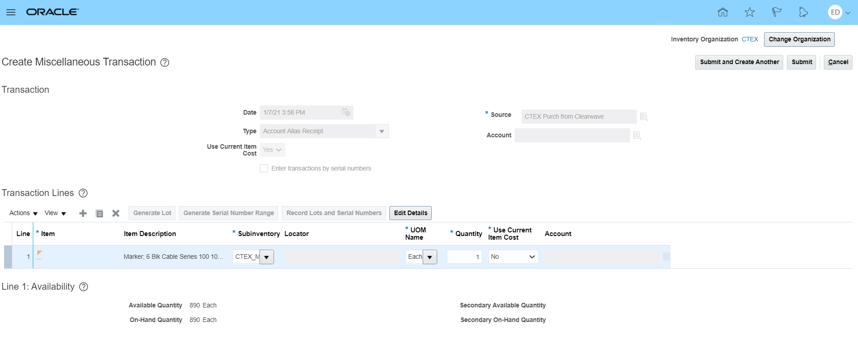
To add additional items, select the Add icon to add another line item and repeat the steps above
- Click the Submit button to display the Confirmation window.
The system displays the message: Your transaction processed with no issues.

- Click the OK button to accept the message and return to the Inventory Management screen.
- You have completed this transaction.

Process a Third-Party Sale Using COMMON Inventory:

Business Procedure Description:
The purpose of this transaction is to process a third-party sale with a receipt using COMMON inventory

Prerequisites:
None

Output/Next Steps:
Third party sale is processed using MAIN or AVA subinventory

Tips/Additional Information:
None

- Log into Oracle and select the Inventory Management icon to go to the Inventory Management screen.

- Click the Tasks icon :
- In the Inventory section, select Create Miscellaneous Transaction to go to the Create Miscellaneous Transaction screen.
A Select Organization window may display once you access the Create Miscellaneous Transaction screen. Enter the appropriate 4 digit code (e.g. CBAY) in the Organization field and click the OK button to continue.

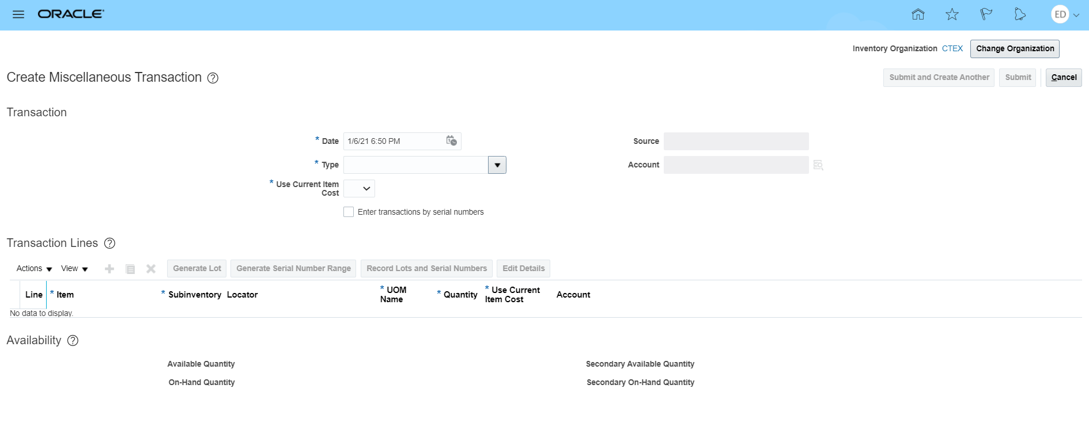
- In the Type field, click the drop-down arrow and select Account Alias Issue.
- In the Use Current Item Cost field, click the drop-down arrow and select Yes.
- In the Source field, type: 4-digit code Third-Party Sale (e.g. CXXXX Third-Party Sale).
- Click the Select: Source icon to display the Source window.
- Click the Search button .
- Click the OK button to return to the Create Miscellaneous Transaction screen.
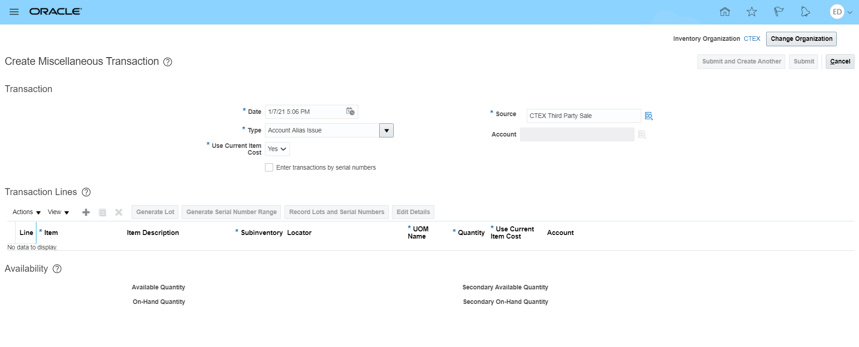
- In the Transaction Lines section, select the Add icon to add a line item.
Is it recommended that you add the Item Description column to your transaction. To add the Item Description column:
- Click the View drop-down arrow
- Select Columns
- Scroll to the bottom of the list and select Item Description

- Enter the Item number in the Item field
- Click the drop-down arrow in the Subinventory field and select MAIN or AVA
- Click in the Quantity field and enter the quantity being sold.
- Click the Edit Details button to go to the Create Miscellaneous Transaction Line: 1 screen.

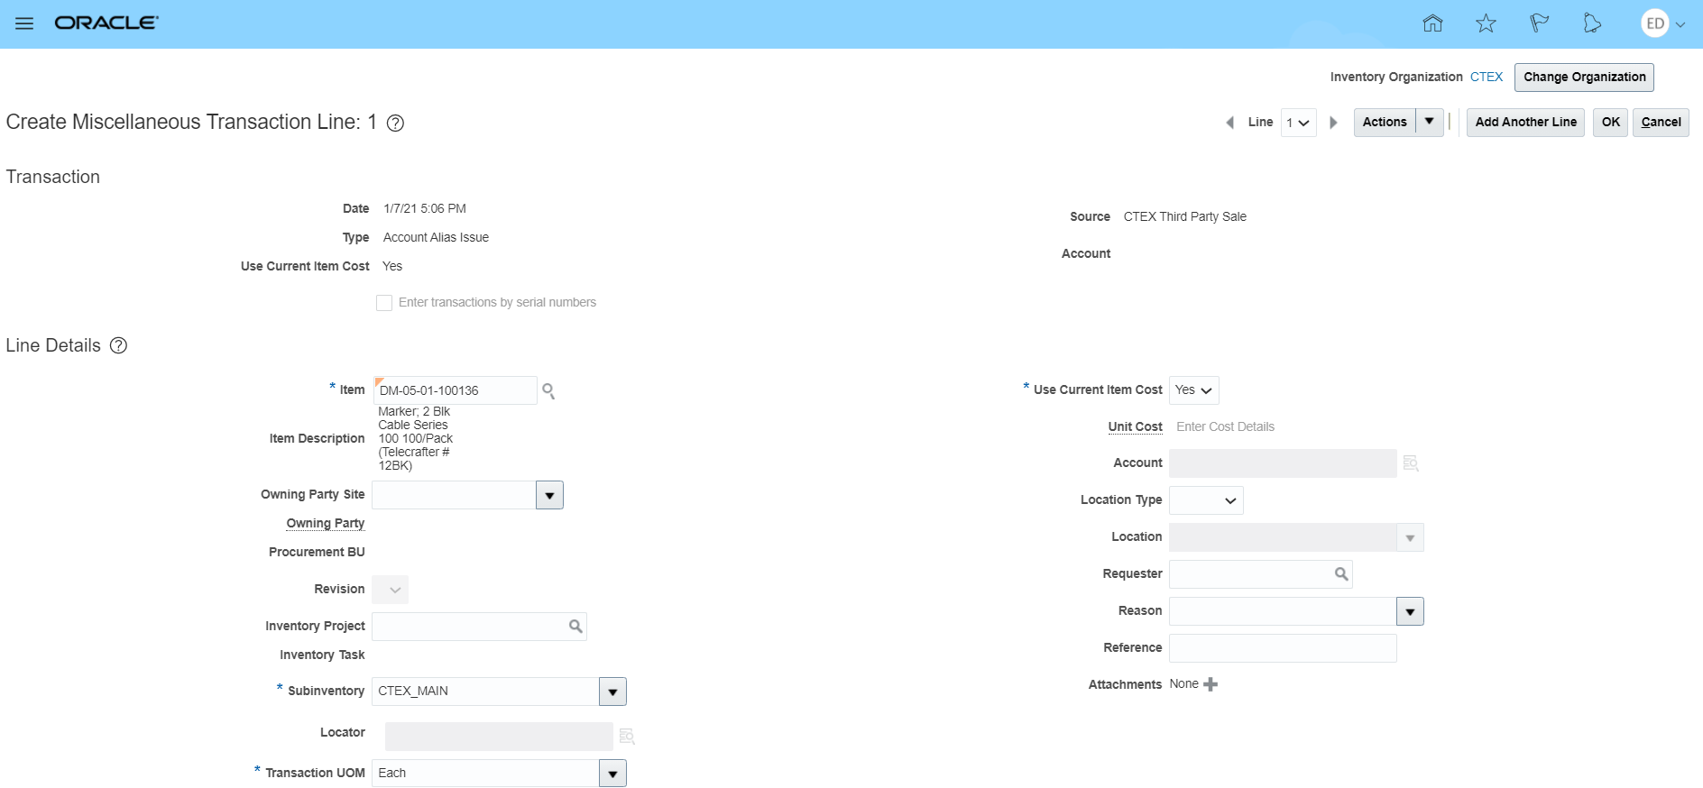
- In the Line Details section, enter the Third-Party Company Name in the Reference field.
- Click the OK button to return to the Create Miscellaneous Transaction screen.
To add additional items, select the Add icon to add another line item and repeat the steps above
- Click the Submit button to display the Confirmation window.
The system displays the message: Your transaction processed with no issues.

- Click the OK button to accept the message and return to the Inventory Management screen.
- You have completed this transaction.

Where to get more information

Job aids and additional support information are available on SharePoint:
[Enter final SharePoint URL]

For assistance with
Oracle
[Enter contact details]

Requisitions (for Entry and procedural steps)
[Enter contact details]

All other CableOne Processes
[ Enter contact details]

IT HelpDesk
[Enter contact details]

